# **Project Proposal**

## TEAM:

1. Bob Hammond
2. Lawrence Yates
3. Lori Bruce

## TOPIC and RATIONALE

We have decided to great a map of marijuana dispensaries in the state of Michigan. We talked about a heat map to show the concentration of stores and another of the location pins with hover information for each store. We have all noticed the uptick of dispensaries in our area and we thought it would be interesting to display the information to satisfy our curiosity and share it with others.

## METADATA

We plan to scrape from one of the inspiration pages. Here is a sample:

<div class="col-xs-7" style="margin: 0 -10px 0 -10px;">

<h3>

<a class="featured-listing-store-name" href="/michigan/marijuana-dispensaries/douglas/

green-koi-provisioning/" target="_blank">Green Koi Provisioning</a>

</h3>

<span>435 Blue Star Hwy Ste B</span><br/>

<span>Douglas, MI 49406</span><br/>

<span class="store-phone"><i style="color: #588033;" class="fa fa-phone"></i>  
 <a target= "_blank" href="tel:+1-269-206-3305">(269) 206-3305</a></span><br/>

</div>

## SOME DATA SOURCES

<https://www.programmableweb.com/api/leafly-rest-api>

## INSPIRATION

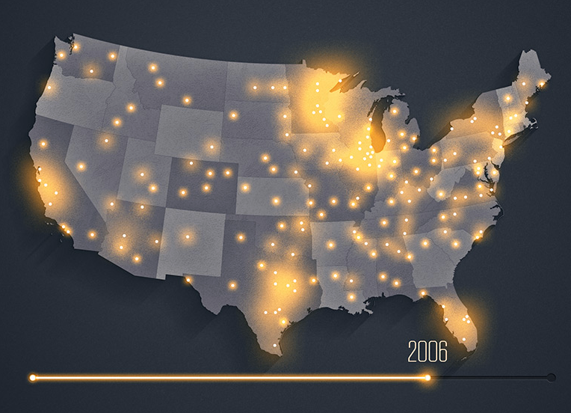

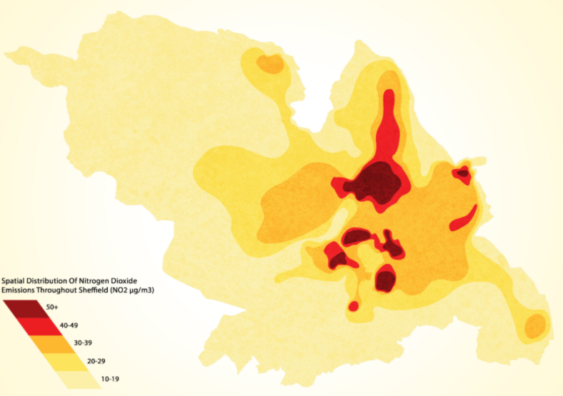

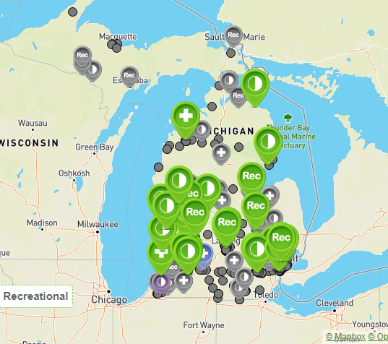

<https://mjbizdaily.com/charts/>

<https://weedmaps.com/dispensaries/in/united-states>

<https://365datascience.com/trending/data-visualization-project-ideas/>

<https://potguide.com/michigan/marijuana-dispensaries/>

## PRIME GitHub REPOSITORY

<https://github.com/claws425/data_viz_project.git>